A Recipe For:

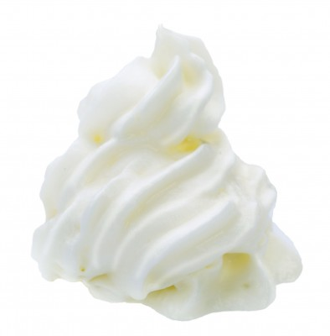 

# Whipped Cream

**From the Kitchen of:** Doug

**Servings:** A group

**Prep Time:** 20 min **Bake Time:** **Bake Temp:**

**Ingredients:**

* 1 cup heavy cream
* ¼ cup sugar
* ½ tsp vanilla

**Directions:**

Whip cream and sugar in a chilled bowl. Add vanilla and whip til peaks appear.

Refrigerate until ready to use.